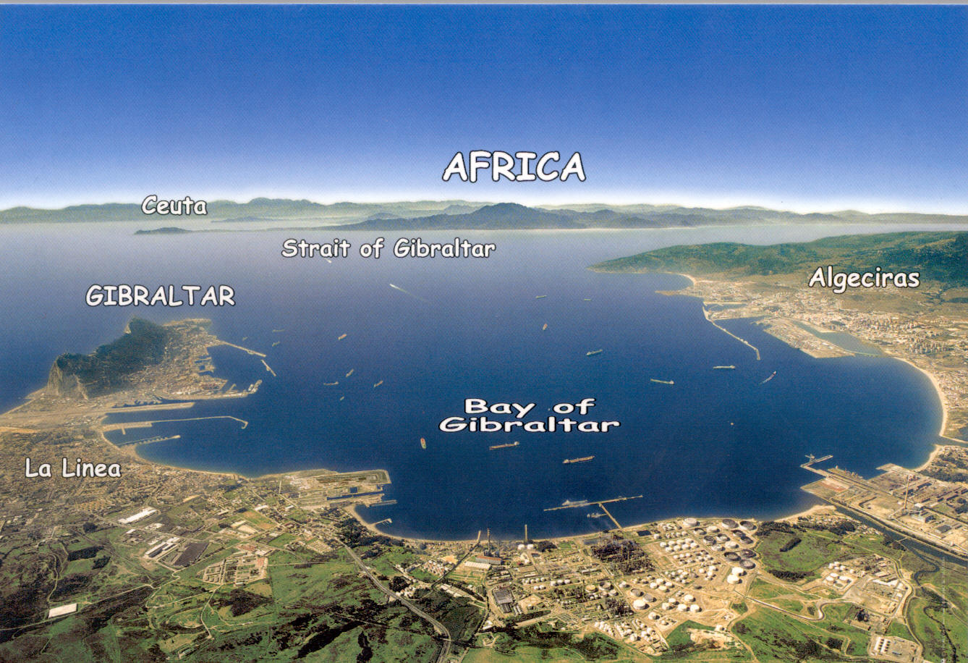
Citizens of the densely populated Campo de Gibraltar live in a highly industrialized area. The area is situated in the South of Spain next to the overseas UK territory of Gibraltar. The huge industrial complex is emitting a wide variety of toxic compounds over the nearby townspeople and environment. This is verified by the European Pollutant Emission Register.

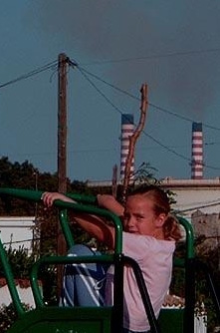
CEPSA S.A. is the largest firm on the industrial complex. CEPSA refines oil and manufactures a variety of petrochemicals, including aviation fuel. The CEPSA refinery in the Campo de Gibraltar is one of the biggest and dirtiest in Europe. For example, this refinery is the single largest source of benzene emissions in Spain, at 43 tonnes per year. In 2004, Citizens proved via an independent air quality sampling programme that emissions regularly exceed legal limits. For example, benzene in the vicinity of the CEPSA refinery has been measured at 110 micrograms/m³, which is 22 times higher than the limit prescribed by the EU Directive 2000/69 (5 micrograms/m³). Benzene is known to be responsible for a number of serious diseases, and is linked with various types of leukaemia, respiratory problems, skin problems, and blood disorders.

The people of the Campo de Gibraltar have been breathing this heavily polluted air with significant risks to their health for decades. The allergic asthma rate amongst children and the overall mortality rate are the highest in Spain; the mortality rate is 20% above the national average,. In the 21st century, oil refinery workers and their families or people just living on the fence line of these industries should not have to risk their health. Furthermore, heavy air pollution limits other economic opportunities for residents of the area, such as tourism, agriculture or fisheries.

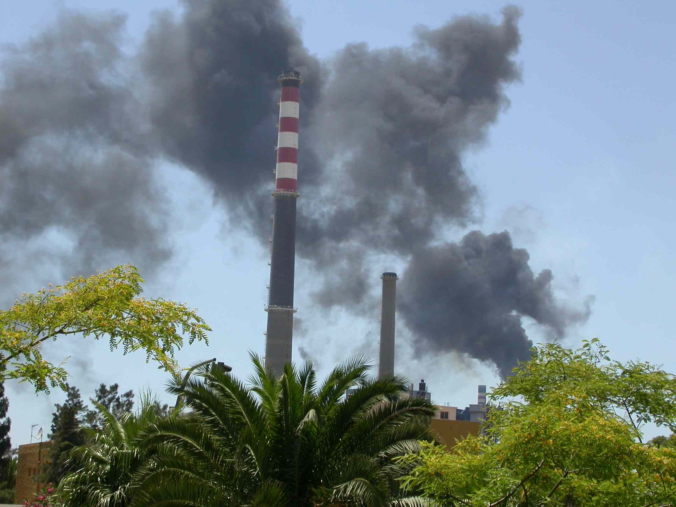
CEPSA's Gibraltar refinery was built in 1969, and has expanded significantly since then. The refinery is one of the biggest in Europe, with a production capacity twice that of other European oil refineries.

CEPSA's main shareholder is TOTAL (45,28% out of share capital), a company with an admirable Socially Responsible Investment Policy - "Total is committed to achieving the best possible financial performance while at the same time setting new benchmarks for societal and environmental responsibility". TOTAL and CEPSA have achieved their first goal, as CEPSA's reported profit in 2005 was 2 billion euros, and TOTAL's profit in 2005 was 12.6 billion euros - more than 1.5 million euros per hour. Unfortunately TOTAL has also set an environmental benchmark: the Gibraltar Refinery is the worst source of benzene in Spain. CEPSA breaks all European pollution records for typical refinery pollutants like, Sulfur Oxides (SOx), Volatile Organic Compounds (VOCs) and Benzene. iii

Figure 1

Based on data that refineries across Europe are required to report to the European Pollutant Emission Register, Figure 1 clearly shows that the CEPSA refinery is much dirtier than other European refineries.

Per tonne of oil refined, the Gibraltar refinery pollutes:
- 4 times more benzene than TOTAL's Grandpuits refinery in France
- 7 times more benzene than TOTAL's Vlissingen refinery in the Netherlands
- 9 times more benzene than the Deutsche Shell refinery in Rheinland

CEPSA's Gibraltar refinery also produces fifty times more Volatile Organic Compounds than the Deutsche Shell refinery, per tonne of oil refined.

When considering production quantities, per tonne, CEPSA Gibraltar Refinery pollutes:
- 10 times more benzene than TOTAL's Grandpuits refinery in France
- 19 times more benzene than TOTAL's Vlissingen refinery in the Netherlands
- 12 times more benzene than the Deutsche Shell refinery in Rheinland

The Banco Santander Central Hispano S.A. is CEPSA´s second largest shareholder (37,27 %). The bank has many offices in the area and surely does not want to expose their employees and bank account holders to unacceptable air pollution. The Banco Santander has, as a main shareholder, the power to influence CEPSA´s policies and should therefore demand for urgent environmental upgrading of the Gibraltar refinery.

The European Investment Bank (EIB), the long-term financing institution of the European Union (EU), provides considerable loans to CEPSA. At least 5 different loans were provided in 2000 and 2001 summing up to a total of 215 million Euros. Most of the money was used for financing production expansion of the CEPSA petrochemicals plants in the South of Spain Lending money for production increase to a substandard refinery that furthermore exceeds the EU´s own pollution limits runs contrary to the principles of sustainable development set by the lender.

The solution to this appalling situation is simple. The technology to curb the pollution exists. Money is clearly available. We just need the investors and customers of CEPSA to provide the will, and we need it now!

Citizens of the Campo de Gibraltar deserve:
- An immediate cessation of all illegal and cost-cutting practices which are placing people’s health and lives at risk
- Shareholders (TOTAL and Banco Santander) demand CEPSA to act responsibly and to upgrade the Gibraltar refinery to European standards
- No further industrial development as saturation levels have been reached
- The EIB to stop lending money to CEPSA for production increase but to reallocate these loans to pollution reduction technologies
- Immediate and ongoing investment in pollution control technology by the refinery and other industries so that the same standards of the average European refinery can be met and
- Customers to hold CEPSA accountable to act in accordance with the promises in their Socially Responsible Investment policies (See Total and CEPSA policy statements)………

In the short term, improvement will be measured by compliance with current EU environmental legislation. The European Commission maintains that the CEPSA Refinery does fall within the scope of 96/61/EC concerning Integrated Pollution Prevention and Control (IPPC Directive). Being an existing installation as defined in the Directive, it needs to comply with all requirements of the Directive by 30 October 2007 at the latest. However, full compliance with Directive 96/61/EC would already be required if the operation of the installation concerned had been substantially changed. It is clear from the almost doubling in production capacity and extension into a variety of petrochemical industries that CEPSA Gibraltar has substantially changed its operations and therefore nullifies its “Grandfather Clause” status.

In the longer term, success will be measured by necessary improvement in human health and biodiversity in the regions of the Campo de Gibraltar.

For more information on hard data on refinery comparison and results of the citizen’s independent air quality sampling programme please contact the focal point of the transborder Bay Bucket Brigade at www.esg-gib.net

2006, Press release after epidemiological study.
? 2004, J Benach, Y. Yasui, J M Martinez, C Borrell, M I Pasarín, A Daponte. The Geography of the highest mortality areas in Spain: a striking cluster in the southwestern region of the country. Occup Environ Med 2004; 61:280-281
2006, European Pollutant Emission Register NACE Code 23.20
TOTAL Socially Responsible Investment Policy http://www.total.com/en/finance/responsible_investment
The EIB website.

